

## Topic: Client Information Form (CIF)

Have you ever encountered a CIF in your search results? Even if your department doesn’t use CIFs, you may find them in your search results from time to time.

CIFs are identified by green document type icons with the letters, “CIF” in the middle.

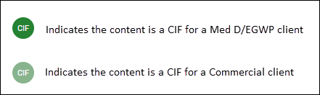

CIFs contains client specific information and are primarily used by Customer Care to handle calls, however they are also visible to all theSource users.

**What will I find in a CIF?**

CIFs contain a variety of client-specific information as well as links to related documents.

**How do I find a CIF?**

When searching for a CIF there are a couple of ways to search:

Client code or Client name.

* For best results, use the “Client” search type to show only CIFs in the search results.
* If you are unable to find the CIF you are looking for using the Client Code or Client Name, try combining both in your search keywords to help boost the CIF to the top of the results list.

**What do I do if I have feedback on a CIF?**

If you have a suggestion to improve a CIF, use the feedback option in theSource. Be careful not to include any member PHI (protected health information).

* Refer to Submitting Feedback in theSource Job Aid for more details, including how to report an issue or trend impacting a client.

 Your next challenge on the quest to becoming a Certified theSource Wizard is to try using the above search tips the next time you need to locate a CIF.

Access the Become a Certified theSource Wizard: Index for a list of all the topics we’ve covered.

Not to Be Reproduced or Disclosed to Others without Prior Written Approval

**ELECTRONIC DATA = OFFICIAL VERSION / PAPER COPY = INFORMATIONAL ONLY**